Thank you for your leadership and willingness to serve at your district meeting! Whether your district meets for a program and includes speakers from education organizations or just allows organizations to display materials on tables, please use these guidelines to assist you.
Preparation
- Contact the person in charge to see if you can set up a table and find out when and where the district meeting will be held. Ask if you could speak to the staff on behalf of Christian Educators. If they agree, get back to your volunteer rep coordinator to discuss the presentation. Be sure to ask the contact person at your district how much time you will have to speak.
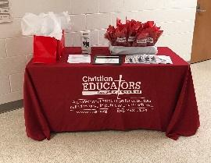
- Normally your table will need only a few materials as about 10-15% of the staff will stop to browse or pick up materials. The table materials may include:
  - Blue applications
  - Membership fliers
  - CE post-it notepads
  - Bookmarks
  - Ink pens
  - FAQ sheets
You also have the option to have a giveaway. We will reimburse you for reasonable costs (let us know in advance the estimated cost).
- Read through the FAQ sheet to familiarize yourself with potential questions.
- If there are other members in your district, ask one or two of them to join you at the table. We will provide them with a free shirt like yours, so let us know their names and shirt sizes as soon as possible.
At the Meeting
- If you can set up a table, use the tablecloth and display your materials.
- Be prepared to briefly state why you have chosen to be a member. As you stand at the table, you can explain to those who stop by how Christian Educators offers more than protection, it becomes a ministry partner to live out their calling.
- Ask them to pray about their decision concerning which teacher association to be a part of and ask them to read the FAQ sheet and call you with any questions.
- For those who are interested in joining, have them fill out the top part of the membership page and return it to you (before leaving).
Follow Up
- Send a follow-up email to those who expressed interest to see if you can help them or answer questions. We can assist you with help with answers.
- Please text a photo of returned membership forms to 888-798-1124.
- Please email us after the meeting to let us know how the meeting went and what materials you have left over. Thank you again for all your help!

